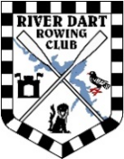 |  | Club Merchandise Order Form
 |  | Name:
 |  | Date:
1. Download and complete the order form and calculate the total cost of your order
2. Transfer the monies to RDRC bank account by BACS a/c no: 33022976 Sort code: 52-30-20
3. Reference your payment with your surname and MERCH
4. Return your order form to toriorc@gmail.com by Friday 5th December 2025 for a Christmas order

PLEASE NOTE: NO ORDER WILL BE PROCESSED WITHOUT PRIOR PAYMENT

Hat type | Size | Colour | Description | Cost | Quantity | Size if relevant | Total Cost
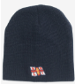 | one size | Navy | 50% acrylic 50% recycled content. RNLI Logo + Club Logo. Cost includes donation to RNLI. | £15
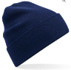 | one size | Navy | 100% organic cotton. Double layer knit. Dual style - cuffed or slouch. Club Logo. | £12.50
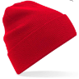 | one size | Red | 100% organic cotton. Double layer knit. Dual style - cuffed or slouch. Club Logo. | £12.50
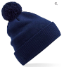 | one size | Navy | 100% organic cotton. Double layer knit. Dual style - cuffed or slouch. Club logo. | £12.50
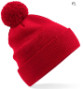 | one size | Red | 100% organic cotton. Double layer knit. Dual style - cuffed or slouch. Club logo. | £12.50
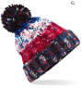 | one size | Multi | Heavy, mulit-yarn cable knit. Shearling thermal band for extra warmth. Club logo. | £12.50
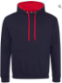 | XS - 5XL | Navy | Quality navy hoody with red hood inner. 80% ringspun cotton / 20% polyester. Front pouch pocket. Embroidered club logo on breast and back. | £35.00
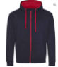 | S-XXL | Navy | Quality navy zoody with red hood inner. 80% ringspun cotton / 20% polyester. Embroidered club logo on breast and back. | £35.00
 |  |  |  |  |  | Grand Total

